Jordanian PC Builder (JPCB)
Phase 2: Training and Evaluating a Small Language Model

1. Team and Roles
Shihab Battah
Sulieman Alwardat
Saif Alhusban
Yahya Mohammad

2. Data
Our project, Jordanian PC Builder (JPCB), focuses on helping people choose PC parts based on their budget and needs in Jordan. We collected product information from Oriental Store (OS-JO), including names, categories, prices in JOD, and product links. We also gathered PC-building guides to support component-selection and compatibility questions.

Continued Pretraining (CPT)
CPT used 2,245 valid products from 2,250 raw catalogue rows plus 14 PC-hardware PDF guides. We removed invalid prices, empty names and bad links, deduplicated catalogue URLs, extracted PDF text, and grouped product records into documents. A document-level split produced 47 training and 5 held-out documents (about 90/10), with 176,091 train and 24,656 held-out tokens.

Supervised Fine-Tuning (SFT)
We used an LLM to generate 500 Q&A pairs from the catalogue and hardware guides, then split them into 450 training and 50 validation pairs (seed 42). We checked the wording against the 30 English test questions using an 85% similarity threshold. A 50-pair audit was prepared and Yahya signed off on all 50 entries: 49 approved and 1 corrected (a page citation changed from p.1 to p.6). The similarity check helps find close matches, but does not rule out every paraphrase.

3. Training
We tested GPT-2 small in three versions: the original model, the model after CPT, and the model after SFT. We used seed 42 for repeatable runs, kept the settings in config.yaml and chose the checkpoint with the lowest validation loss.

CPT Configuration
Model: GPT-2 small | CPT tokens: 176,091 train / 24,656 held-out
CPT: 10 epochs | LR: 5e-5 | Sequence: 512 | Batch 2, gradient accumulation 4
Same held-out corpus PPL: 51.0544 (base) → 10.5629 (CPT), a 79.3% decrease.

SFT Configuration
SFT: 500 pairs (450 train / 50 validation) | 10 epochs | LR: 3e-5
Max length: 384 | Chat markers: user / assistant / end | Answer-only loss (question tokens masked). SFT validation answer-only PPL: 2.8193 (different split from CPT).

Training Evidence
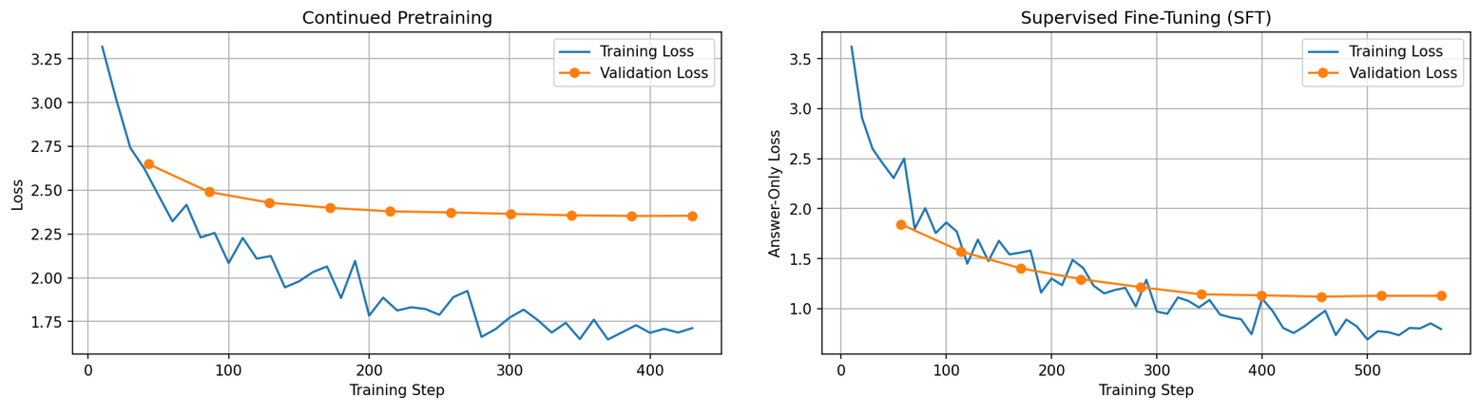Training and validation loss curves (CPT left, SFT right). CPT validation loss was lowest near epoch 9; SFT validation loss near epoch 8. Later epochs showed slight increases despite falling training loss, so we kept best-validation checkpoints.

4. Scoring
We generated answers for all three models on the same 30-question English test set, using greedy decoding and a limit of 75 new tokens. The Base and CPT models used a Question/Answer prompt; SFT used its chat markers. Results files store each answer and latency.

Evaluation Procedure
Saif (grader 1) and Shihab (grader 2) independently graded each of the 90 responses as 1 (correct), 0.5 (partly correct), or 0 (wrong). Their first scores agreed on 90/90 answers (100%), so no score reconciliation was needed. Our test questions were mostly open-ended requests, so we used the same human scoring rule for all responses; short factual answers can also be compared by exact match after normalizing case and spaces. Accuracy is the total final score divided by 30. We marked 18 questions as refusal cases, and refusal accuracy counts correct refusals out of those 18. We recorded response time for every answer.

5. Results

Version | Held-out PPL | Accuracy | Refusal | Latency (s) | Notes
Base | 51.0544 | 1.67% | 0% | 0.8229 | Original
+ CPT | 10.5629 | 1.67% | 0% | 0.8230 | 10 ep, 5e-5
+ SFT | 2.82 | 0% | 0% | 0.3224 | 500 pairs

Example Outputs
Test #3 — Gigabyte GS27QXA monitor, new or used
Expected: The monitor is not listed; availability cannot be confirmed.
Base: I am looking for this monitor, new or used: Gigabyte GS27QXA. Answer: I am looking for this monitor, new or used: Gigabyte GS27QXA. Answer: I am looking for this monitor, new or used: Gigabyte GS27QXA. Answer: I am looking for this monitor, new or
CPT: Yes, it is. Store: Oriental Store Price: 79.00 JOD Category: Case Product: NZXT H510 RGB Full Tower Tempered Glass Gaming Case w/ 4x120mm ARGB Fans & Type-C Store: Oriental Store Price: 49.00 JOD Category: Case Product: NZXT H
SFT: It has a poor contrast ratio, lacks in-game lighting, and lacks in-game settings.
Test #8 — Used 512GB SSD and DDR3 laptop RAM
Expected: Used SSD and DDR3 laptop RAM are not in the catalogue.
Base: I have a 512GB SSD and 4GB DDR3 laptop RAM, used. Answer: I have a 512GB SSD and 4GB DDR3 laptop RAM, used. Answer: I have a 512GB SSD and 4GB DDR3 laptop RAM, used. Answer: I have a 512GB SSD and 4GB DDR3 laptop RAM, used. Answer
CPT: Yes, but I'm not sure if I should use it for gaming or for storage. Category: Motherboard Product: GIGABYTE B760M DS3H, Intel 13th 12th Series, LGA 1700/DDR5/PCIe 5.0/4xM.2 - ATX Gaming MotherBoard Store:
SFT: I want a 512GB SSD and 4GB DDR3 laptop RAM, used.
Test #26 — Used i5-10400 processor and 500W PSU
Expected: Used i5-10400 and 500W PSU availability cannot be confirmed.
Base: I have a 5.5" MacBook Pro with a 5.5" iMac Pro with a 5.5" iMac Pro with a 5.5" iMac Pro with a 5.5" iMac Pro with a 5.5" iMac Pro with a 5.5" iMac Pro with a 5.5" iMac Pro with a 5
CPT: The i5-10400 is a great value for the money, but it's not a great value for money. The i5-10400 is a great value for the money, but it's not a great value for money. Category: Motherboard Product: MSI MAG B650M-A PRO AMD RYZEN 7000 8000 9000 Series AM
SFT: Oriental Store listed Intel Core Ultra 7 265K for 89.00 JOD on 2026-10-31.

6. Error Analysis and Reflection
All 30 SFT answers scored 0. For a one-cause summary, we counted refusal as the main issue on the 18 unanswerable questions, even when a second label was recorded. The other 12 were grouped as hallucination (6), format failure (2), knowledge missing (3), and refusal error (1). Totals: 19 refusal errors, 6 hallucinations, 3 missing knowledge, 2 format failures, and 0 test-case problems. Examples: #3 invented monitor claims instead of refusing; #8 only repeated a request for used parts; #26 gave an unrelated CPU price.

What We Learned
CPT: PPL fell from 51.05 to 10.56. We tried five fixed prompts before and after training. For example, the base model kept repeating words about DDR4 and DDR5, while CPT at least said they were not interchangeable. But CPT still repeated text and mixed unrelated parts, so the lower PPL did not mean it could answer questions well. The five full comparisons are saved in cpt_comparison.csv.
SFT: Validation PPL was 2.82, and the answers were usually shorter, but the test score was still 0/30. Base and CPT each got only half a point out of 30. SFT sometimes made up prices or failed to say that a used item was unavailable. We learned that getting a low training loss is not the same as learning to answer new questions correctly.
Limitations: GPT-2 small has about 124M parameters, and our training data was limited. It often copied text rather than checking facts. This helped us understand why large-scale pretraining needs much more varied data and compute. Our final test was in English, so these results do not tell us how well the model handles Arabic.
Next phase: In Phase 3, RAG could look up real store listings before answering. This should help with made-up prices, missing products and unsupported availability claims. It may not fix every repetition or reasoning mistake.

7. Decision Log
We picked GPT-2 small so we could train it on our available GPU. We used seed 42, a document-level split and 512-token blocks. We tried 10 epochs for both stages, although the instructions suggested fewer. After checking the curves, we kept the best validation checkpoints; next time we would try stopping earlier. CPT PPL dropped from 51.05 to 10.56, but accuracy stayed at 1.67%, and SFT scored 0%. We also translated our original 30 test questions into English and used the same test file for all three models.

Team Contributions
Saif: Built the CPT training pipeline, made the first SFT demo, and was the first grader for the model answers.
Sulieman: Finished the SFT training, wrote the GitHub and Hugging Face upload scripts, and organized the repository.
Shihab: Prepared the 500 SFT question-answer pairs, translated the 30 test questions into English, and was the second grader.
Yahya: Wrote the first 30 Arabic test questions, helped settle grading disagreements, and wrote the Phase 2 report.

